|  |  |  |
| --- | --- | --- |
| Response to:  Intel Corporation, Internet of Things Group (IOTG)  Project Title:  Computer Vision for Retail    Submitted on:  12-Aug-2016 | | |
|  |  | Bosch_RGB_L_transparent |
| |  |  | | --- | --- | | Intel Corporation, Internet of Things Group (IOTG), USA | M/s Robert Bosch Engineering and Business Solutions Private Ltd. | | Name: Mr. Sanjay Addicam | Name: Mahesh Chikodi | | *Designation: Principal Engineer, IOTG* | Designation: Head of Sales, UK | |  | Telephone: +44-1895-83-8653 | | *Phoenix, Arizona* | Mobile : +44-779-296-4789 | | E-mail: [Addicam.V.Sanjay@intel.com](mailto:Addicam.V.Sanjay@intel.com) | E-mail : Mahesh.Chikodi2@uk.bosch.com | | *URL:* [*www.intel.com*](http://www.intel.com) | *URL:* www.bosch.com | | *Proposal Submission Date:* ***17-Aug-2016*** | |  |  |  | | --- | --- | | Validity | 3 months from date of submission | | Confidentiality – Copyright @ RBEI  This document and no part of it to be reproduced by any means or transmitted without the written permission of RBEI. This information is considered privileged and confidential, and its release would offer substantial benefit to competitors offering similar services. This document includes descriptions of methodologies and concepts derived through substantial research and development efforts. Therefore, it is the position of RBEI. that the use or release of the information contained in this document other than an evaluation of its contents as a basis for contract award is prohibited, and materials herein are not considered subject to release. | | | | |

Table of Contents

[1. Executive Summary 2](#_Toc459217059)

[1.1 The RBEI Bosch Benefit 2](#_Toc459217060)

[1.2 About Bosch 3](#_Toc459217061)

[1.3 Bosch in the Internet of Things 3](#_Toc459217062)

[1.4 The Bosch Commitment 4](#_Toc459217063)

[2. Project Overview 5](#_Toc459217064)

[2.1 Background 5](#_Toc459217065)

[2.2 Project Scope and Details 5](#_Toc459217066)

[2.3 Functional Scope 6](#_Toc459217067)

[2.4 Technical Scope 7](#_Toc459217068)

[2.4.1 System Setup for Computer Vision Pipeline 7](#_Toc459217069)

[2.4.2 Camera Calibration 7](#_Toc459217070)

[2.4.3 Image Stitching 8](#_Toc459217071)

[2.4.4 Object Detection (Shelf, Tables, etc.) 8](#_Toc459217072)

[2.4.5 Change Detection 10](#_Toc459217073)

[2.4.6 Depth estimation from Multi View Geometry 10](#_Toc459217074)

[2.4.7 Relative Distance/Angle between Antenna and Objects 11](#_Toc459217075)

[2.4.8 Clustering 12](#_Toc459217076)

[2.4.9 Mapping 13](#_Toc459217077)

[2.4.10 State Change Detection 15](#_Toc459217078)

[2.4.11 Reporting 16](#_Toc459217079)

[3. Implementation Approach & Methodology 17](#_Toc459217080)

[3.1 Agile Development Methodology 17](#_Toc459217081)

[3.2 Requirements Management (Stories) 17](#_Toc459217082)

[3.3 Project Steering and Control 18](#_Toc459217083)

[3.4 Change Management 18](#_Toc459217084)

[3.5 Quality Gates / Sprint Assessment 18](#_Toc459217085)

[3.6 Testing 18](#_Toc459217086)

[3.7 Sprint Reviews 18](#_Toc459217087)

[3.8 Continuous Code Integration 19](#_Toc459217088)

[3.9 Quality Assurance 19](#_Toc459217089)

[3.10 Development Schedule 20](#_Toc459217090)

[3.11 Proposed Sprint Plan and Activities 21](#_Toc459217091)

[3.12 Deliverables 22](#_Toc459217092)

[4. Additional Details 23](#_Toc459217093)

[4.1 Data Requirement: 23](#_Toc459217094)

[4.2 Model Evaluation and Success Criteria: 23](#_Toc459217095)

[4.3 Out of Scope 23](#_Toc459217096)

[4.4 Assumptions and Dependencies 24](#_Toc459217097)

[4.5 Intellectual Property Rights 24](#_Toc459217098)

[5. Project Management, Reporting and Review Methodology 25](#_Toc459217099)

[5.1 Project Management 25](#_Toc459217100)

[5.2 Project Organization 25](#_Toc459217101)

[5.3 Reporting and Review Methodology 26](#_Toc459217102)

[6. Risk Management Approach and Plan 28](#_Toc459217103)

[6.1 Project Specific Risks and Mitigation 29](#_Toc459217104)

[7. Project Estimation and Commercial Summary 31](#_Toc459217105)

[7.1 Development Project Cost 31](#_Toc459217106)

[7.2 Payment Schedule 31](#_Toc459217107)

[8. Terms and Conditions 32](#_Toc459217108)

[9. Business Contacts 33](#_Toc459217109)

# Executive Summary

Robert Bosch Engineering and Business Solutions Private Ltd (RBEI) wishes to thank **Mr. Sanjay Addicam** of Intel Corporation, USA for providing an opportunity to submit this proposal for development of Computer Vision project for Intel.

Internet of Things Group (IOTG) at Intel Corporation is undertaking an innovation project in order to connect information from cameras and RFID tags to better manage SKUs at retails stores. This will later be offered, upon successful pilot, to Intel’s retailers and brands.

The proposed end objective would help in quicker sorting and redistribution of items inside a store that is part of a broader intelligent and sensing physical store.

Bosch acknowledges the intent and purpose behind this solution framework and would like to support Intel with the full strength of both organizations from a research, technology and engineering perspectives. Given the objective that Intel has, we will come together to support with a roadmap that addresses Intel’s current objectives and future challenges with the required solution.

Bosch will bring together competencies and experience in working in multiple image processing and data analytics projects across industry verticals and we believe that our solution will meet Intel’s objectives.

Performance, Quality, Reliability and Value are key to a strong product strategy. This is the premise for this proposal document from Robert Bosch Engineering and Business Solutions (RBEI) Pvt. Ltd. (Bosch).

## The RBEI Bosch Benefit

RBEI is pleased to submit its proposal to the Computer Vision requirement for Intel. We acknowledge the importance that Intel accords to its partners for its future and we recognize the value of innovation that is needed to sustain and grow an organization such as Intel. The team strongly believes in our ability to be one of the best partners in Intel’s journey towards value growth. We also envision Intel as one of our key strategic customers and are committed to delivering superior value through improved operational efficiency, innovative engineering solutions, competent workforce and flexible business models.

RBEI team will leverage its experience and learnings from working with Intel’s IoTG team on the former Retail Cloud Framework. We believe that our past association will form a strong foundation, which can help the teams work closely towards achieving the end objective of the pilot.

Additionally, the teams brings together competencies in the fields of image processing and analytics, which will help us deliver a seamless output tailored to Intel’s requirement.

## About Bosch

As a leading technology and services company, we take advantage of our global opportunities for strong and meaningful development. Our ambition is to enhance the quality of life with solutions that are both innovative and beneficial. We focus on our core competencies in emerging technologies as well as in products and services for professional and private use.

Interactive link to know more about Bosch: <http://www.bosch.com/worldsite_startpage/en/Bosch_Today.aspx>

Bosch Group took an early strategic step forward into the connected future. The leading international provider of technology and services acquired 'Innovations Software Technology' in 2008 and 'Inubit' in 2011, which furnished it with core technologies on business rules and business process management, a first in the context of the Internet of Things. Today, these software products are part of the Bosch IoT Suite, supplemented by device management and big data processing.

## Bosch in the Internet of Things

**World market leader in sensor technology**

More than one billion MEMS sensors were shipped in 2013. Bosch holds more than 1,000 patents and patent applications related to MEMS technology (micro-electromechanical systems).

**Connected products and new business models**

In Bosch’s vision of the future, each of its electronic products is web-enabled. It already offers numerous connected products as well as new services and apps. The focus of these activities stays true to the Bosch motto “Invented for Life” – innovations should be in people’s interest.

**Bosch already has extensive expertise in hardware and software**

Who will take the lead in the Internet of Things? IT companies or those who are experts in “things”? Bosch is well-established in both worlds: creating reliable products of superior quality that already contain a good amount of intelligent software.

**Lead user and supplier in Industry 4.0**

Bosch is currently realizing and testing use cases for Industry 4.0 in some 50 pilot projects. With over 260 production plants around the world, Bosch has extensive production know-how, stretching from the manufacturing of millions of automotive components to the customized manufacturing of packaging machinery.

**The Bosch Group is an energy market pioneer**

For many years, the Bosch Group has successfully developed and marketed pioneering solutions. These can be harnessed by the energy industry in multiple fields, including electro mobility, wind energy, thermo technology, storage technology, and building technology.

## The Bosch Commitment

Bosch believes in customer delight and is committed to the success of the Computer Vision program. The success of the program is dependent on the three key delight areas of Quality, Cost and Delivery.

A. Quality

* Readiness of the Technology
* Maturity and reliability of the engineering and manufacturing process
* Metrics based assessment

B. Cost

* Lean engineering effort and therefore development budget
* Optimal cost of materials
* Low running costs

C. Delivery

* On-time, on-target, on-spec deliveries
* Single window to entire program
* Ownership of ecosystem, deliverables and commitments

# Project Overview

This section outlines the details related to the project background, proposed scope and perceived technical approach towards attaining the end objective of determining item misplacements inside a retail outlet.

## Background

The overall idea behind this project is to build a self-learning system which can establish ground truth with respect to identification of changes to store layout, and thereafter work with the new layout design to determine possible misplacement of items inside the store.

For this purpose, the project aims to utilize the information provided by video cameras located inside the store – multiple images taken by these cameras need to be stitched together to create a 3D rendering of the store layout. This is then compared with earlier layout history to ascertain whether or not there has been rejig of the store. In case of a layout change, the new position of shelves and tables are determined.

Additionally, the RFID antennae read all tagged clothes in their vicinity, and thereafter the model needs to group or cluster these clothes by utilizing appropriate analytical algorithms. These groups then need to be paired with the identified shelves/racks.

During operational hours of the store, the monitoring module needs to run in order to generate a report of the misplaced clothes.

## Project Scope and Details

The following are the broad modules which will be catered to, towards the realization of the end objective of the project:

1. Stitching of images from video cameras to create a single composite image

2. Object detection in the image to identify shelves and tables

3. Determination of changes to layout (if any)

4. Determination of relative position of shelves with respect to the antennae

5. Utilization of reads from RFID antennae to cluster or group sets of tags

6. Association and mapping of the above groups to the shelves

7. Identification of misplaced items based on the ground truth thus created

Project execution will be from RBEI’s offshore location at Bangalore, with the team requiring store level inputs from Intel team on a need basis for efficient project execution.

End-to-end project delivery responsibility will rest with RBEI, with identified representation from the customer end to enable a smooth handshake and progress of activities as detailed in this proposal.

Further, RBEI proposes to augment the engagement after the proposed project. RBEI shall coordinate a management review with the customer at the end of the project to discuss the roadmap for collaboration and furthering a strategic data analytics engagements with Intel.

* **Estimated Duration**: 6.5 months from kick-off (timeline to be frozen upon acceptance of proposal)
* **Tentative start date**: 15th Sept., 2016
* **Location**: Delivered from Robert Bosch Engineering and Business Solutions, Bangalore
* **Travel**: Currently no travel is planned for the associates involved in the project. (Required travel may be planned on a need basis and billed at actuals)

## Functional Scope

The primary functional blocks of the project are outlined in the block diagram below:

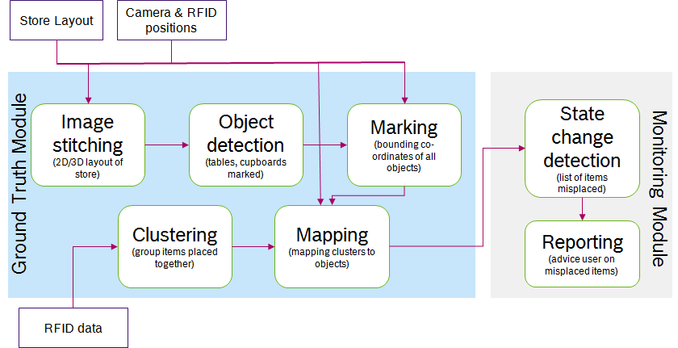

As shown, the overall solution can be divided into two blocks, viz. ground truth module and the monitoring module.

The ground truth module will run every evening during the closing hours of the store in order to establish the changes that have taken place over the last version of the ground truth module.

The monitoring module is designed to work during the store operational hours, and will use the information from ground truth module as a reference to generate the list of items misplaced from their intended location inside the store.

## Technical Scope

### System Setup for Computer Vision Pipeline

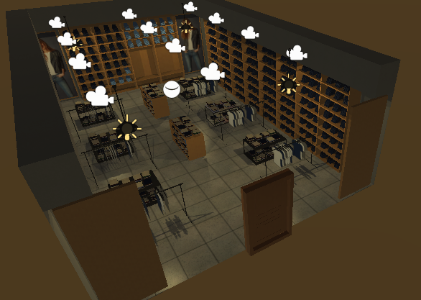

Retail store fixed with ceiling cameras

Each 2D ceiling camera captures the area under it. The position of the 2D Cameras mounted is available and this information can be used for computations in vision pipeline.

### Camera Calibration

The goal of this module is to compute extrinsic and intrinsic parameters of the camera.

Intrinsic parameters aid in correction for the lens distortion. The extrinsic parameters provide the relation between the camera’s natural units (pixels) and the real world units (for example millimeters).

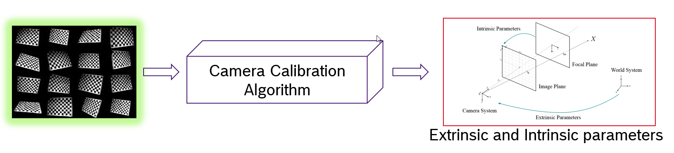

* *Inputs* : Checker board images at different positions in the camera view
* *Output* : **Intrinsic** and **Extrinsic** parameters of the camera
* *Validation* : The acquired images after calibration should be distortion free

### Image Stitching

The goal of this module is to stitch images from an array of cameras mounted on the roof in a sequence into a composite image.

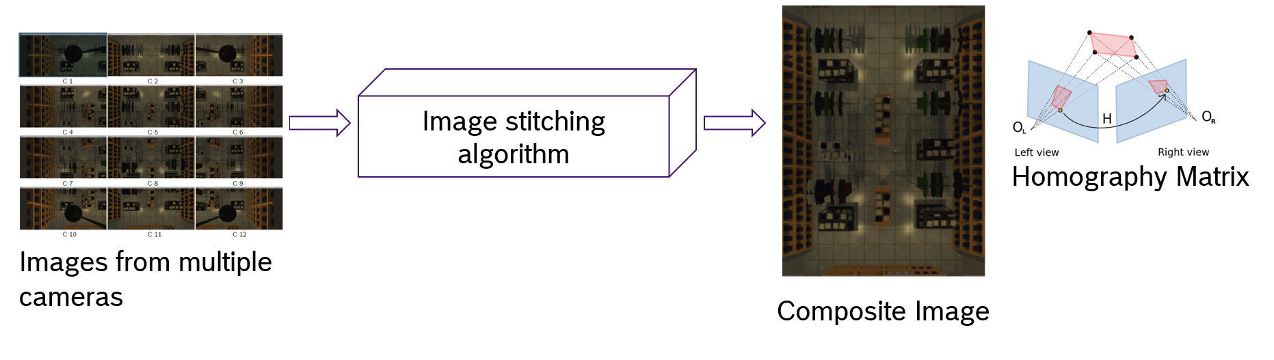

* *Inputs* : Images from multiple camera views
* *Output* : **Composite image** , **Homography Matrix** (can be used for improving robustness)
* *Validation* : The stitched image should not have any distorted content

**Bundle Adjustment:** For improving the overall accuracy of the image stitching phase an appropriate Bundle Adjustment component will be implemented.

### Object Detection (Shelf, Tables, etc.)

#### Object Training Module

The goal of this module is to train **objects of interest** using state of the art machine learning techniques. In this module we choose **HOG features** with **SVM** with large number of positive and negative samples. Adding a Negative hard mining phase improves the robustness of the object training. Multi-class SVM can also be used for training multiple object classes.

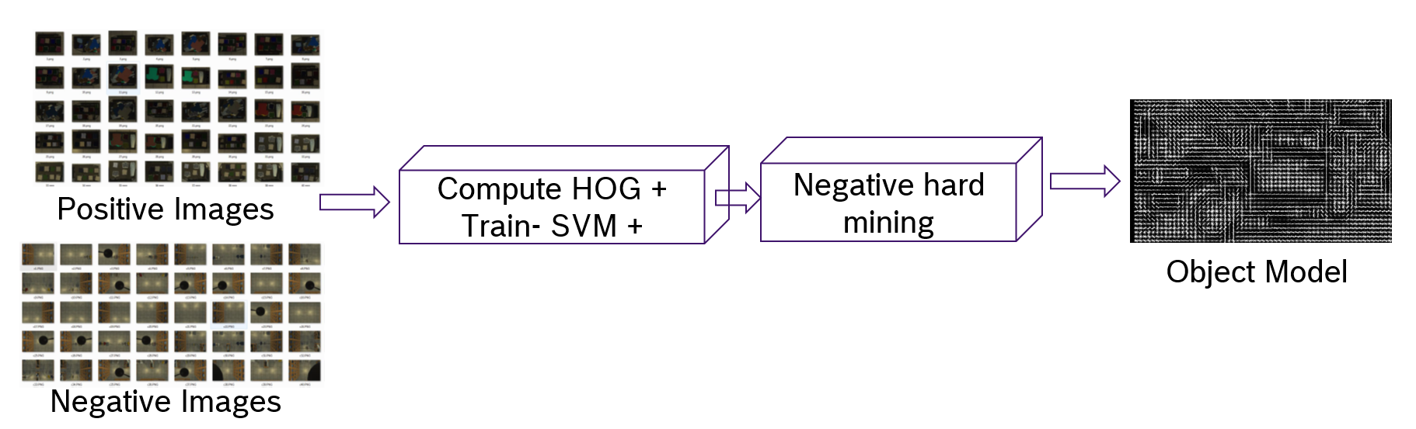

* *Inputs* : Positive Images , Negative Images
* *Output* : Trained Object Model (can be done for multiple objects)
* *Validation* : HOG Visualizer, Use Detection Module (for sample tests)

Other techniques useful for Object Training: **FAST RCNN** will also be evaluated in parallel with current procedure.

**Using RCNN as an alternate strategy for object detection:**

* HOG and RCNN based object detection will perform well if number of train samples are large
* Some example outputs from faster-RCNN.   
  <https://cs.stanford.edu/people/karpathy/rcnn/>  
  Here we can see that people and dogs are detected with different orientations and types.
* RCNN will be robust by training with large variety of data set.
* Possible training data collection:
  + By collecting large data sets  from the showroom with different cases
  + Collecting images using web crawling (python scrappy) by using special keywords  
    <http://scrapy.org/>
  + Virtually generated data using reference training images

#### Object Detection Module

The goal of this module is to detect **objects of interest** using state of the art machine learning techniques. In this module we choose pre-trained data based on **HOG features** with **SVM** (as indicated in previous section).

There can be additional inputs coming from Structural cues of the 2D Image [such as lines (Hough transform), edges, etc...] which can be fused with initial detection results to reject false positives.

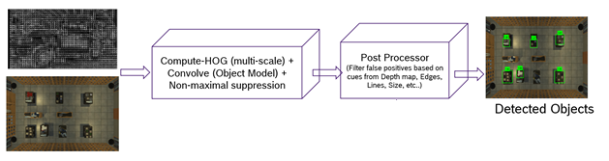

* *Inputs* : Object Model , Target Images
* *Output* : Objects detected with X,Y positions in the Target Image
* *Validation* : Testing with untrained images

Other techniques useful for Object Detection: **FAST RCNN** will also be evaluated in parallel with current procedure.

### Change Detection

The goal of this module is to have focused analytics on the objects that are changed or moved from yesterday’s position. To do this, a standard background subtraction technique (today-yesterday) will be used to highlight only changed content.

* *Inputs* : Composite Image (today), Composite Image (yesterday)
* *Output*: Changes in the objects highlighted
* *Validation*: Manual Testing (with multiple test cases), Simulation in virtual world

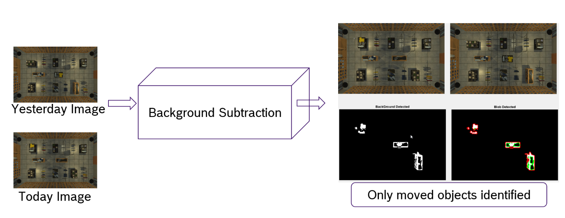

### Depth estimation from Multi View Geometry

The goal of this module is to estimate depth of the changed objects in the scene. Image pair selector module detects the overlap images required for computer vision stereo calls.

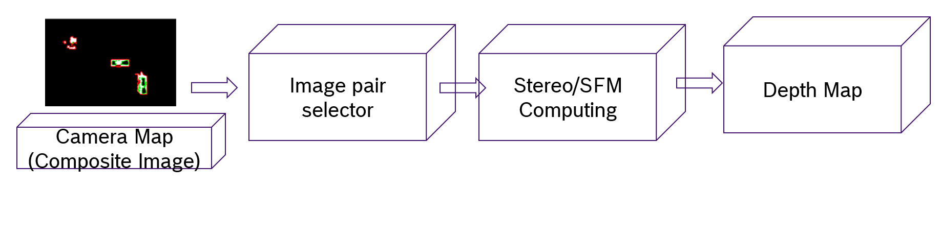

* *Inputs :* Camera Map (Composite Image), Object Coordinates (X,Y)
* *Output :* Depth Map/Depth cues by using Camera pair
* *Validation :* Manual Testing (with multiple test cases)

### Relative Distance/Angle between Antenna and Objects

The goal of this module is to estimate the relative distance between various antenna(e) and object(s) using 2D object information (x, y) and depth information (z).

If one can compute X, Y, Z coordinates of the objects of interest, it is a simple vector calculation to estimate the distance and angle between the object and other antennas.

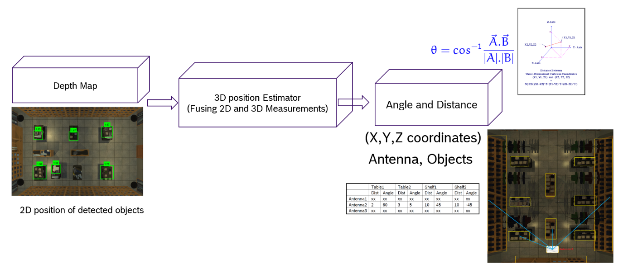

* *Inputs* : 2D coordinate information (X,Y Coordinates of objects detected), Z Coordinate (Stereo / SFM)
* *Output*: Relative Angles, Distances as shown below
* *Validation Criteria*: Simulation in Virtual world (SFM), Testing with real images

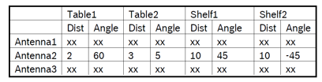

### Clustering

This module takes RFID data from antennae reads and item attributes from RFID lookup database to cluster items (clothes) placed together in a store. This module includes data imputation, identifying similarity or distance measures and clustering.

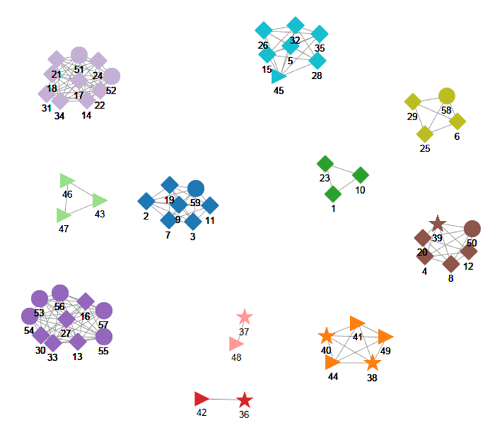

Data imputation:

One of the properties of RFID antenna reads is that, tags which are located farther away from the antennae are read less frequently than tags placed closer. Also, tags located in close proximity might not be read together in every instance. The second issue can be handled using data imputation methods.

Some of the data imputation methods which will be explored are:

* *Collaborative filtering*: This algorithm considers the antennae reads and based on them tries to group items with similar reads together (e.g.: items 1 and 2 are read 80% of the time from antenna-1). In this algorithm, item features (such as size, color etc.) are not considered. We can construct a utility matrix and compute the similarity between items, using some distance (similarity) metric. If the similarity measure between two users is close then these users are similar. We would explore the following similarity metrics, which are typically used in such scenarios: (i) Jaccard similarity; (ii) Cosine similarity; (iii) Pearson correlation-based similarity;

(iv) Manhattan distance; (v) Euclidean distance; (vi) Minkowski metric

#### **Clustering:**

The input from distance measure module is used to cluster items which are placed together in the store. The output of these clusters are compared with ground truth to fine tune the parameters of clustering. Clustering methods like Gaussian mixture models, graph clustering and hierarchical methods will be explored.

Possible approaches for clustering are outlined as follows:

* *Expectation maximization-based approach:*

The number of times an item/RFID tag is read by antenna follows a normal distribution (according to central limit theorem). Therefore, one can assume that each cluster is coming from a Gaussian distribution.

Most of the clusters would intersect with others. There is a strong possibility that standard clustering techniques won’t return accurate clusters. In this case, Expectation-Maximization algorithm (initialized using k-means), which tries to fit the data into Gaussian mixture models, could return accurate clusters. We can consider a sliding window over data streams of RFID reader within a given time interval. One can query which items comply with the ground-truth in SQL using a database procedure.

* *Graph clustering approach:*

Graph clustering is a process of dividing the vertices in a graph into groups or subset of vertices. It is assumed that groups of vertices are well connected within the group and poorly connected with the other groups. Dissimilarity measures across RFID tags can be constructed based on readings by antennae. It can be represented by adjacency list/adjacency matrix/edge list.

Following algorithms can be explored to discover these groups or clusters of vertices:

* *Hierarchical clustering*: This algorithm has two versions, agglomerative and divisive, which produce multi-level clusters represented as dendrograms
* *Random walk based clustering algorithm*: Random walk is based on Markov chain. This algorithms starts at a node and moves randomly to the connected node. It works based on the assumption that if vertices are well connected, we will stay in the same cluster. Some random walk algorithms determine clusters based on mixing time of walks
* *Markov Cluster Algorithm (MCL)*: It is similar to random walk algorithm but works by applying inflation and expansion operators responsible strengthening and weakening of the connections until the algorithm converges
* *Spectral Clustering*: This method is based on eigenvectors corresponding to Laplacian. Spectral methods are computationally intensive
* *Max-flow/Min-Cut*: This algorithm tries to find minimum weight cut which divides the graph into disconnected components.
* *Bisecting k-means*: Algorithm starts with a single cluster with all vertices by bisecting it further at each iteration with topological distance as similarity measure.

Above clustering algorithms will be explored until desired levels of item grouping is obtained

### Mapping

This module maps cluster centroids to objects (tables, cupboards etc.) in the store. The module takes data about store layout, RFID sensor positions, object marking module and cluster centroids. It creates posterior probability distributions for each cluster centroid and tries to determine the object within which a cluster is placed.

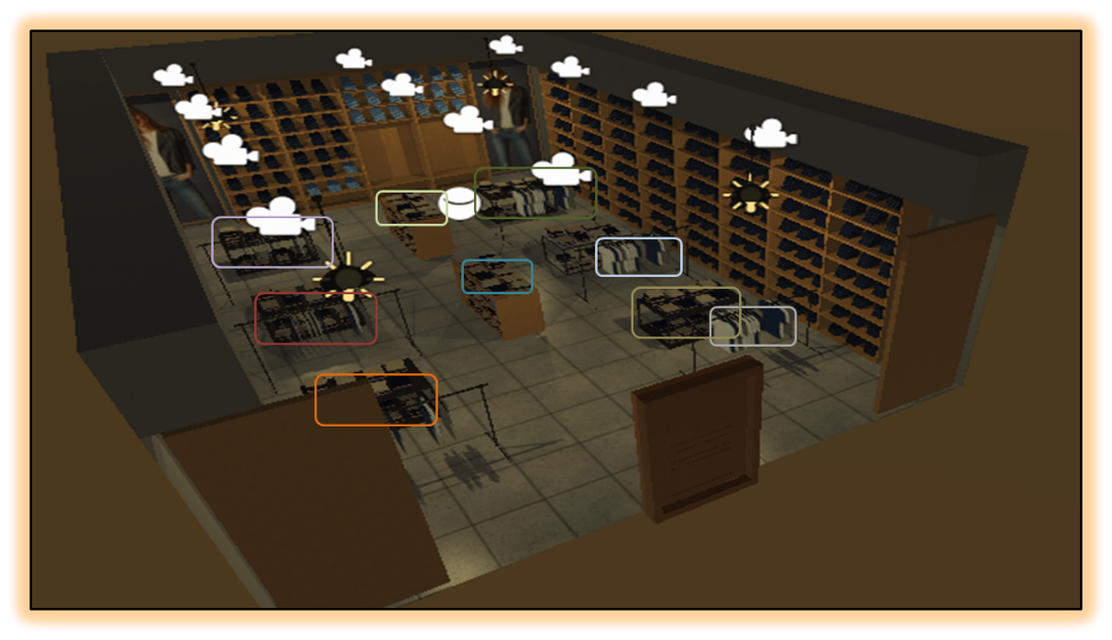

One of the following possible models would be explored to create the probability distribution of cluster centroids:

* *Detection model-based localization*:

This method creates a probability space given the relative position of RFID and the tag. Depending on the cluster centroid reads from various sensors, the most probable location of cluster is identified by merging probability space and object bounding co-ordinates. In case it is possible that reference tags (for each furniture piece) are used, then the *k*-nearest neighbors (kNN) method can be used to group nearby tags by measuring the RSSI at the known (fixed) locations.

Each of the *N* RFID readers has *P* transmission power levels. For the localization of a tag, the readers start with the lowest power level and gradually increase it until they receive a response from the tag. If a reference reader doesn’t receive response even at maximum power, then its term is eliminated from consideration of that antenna’s field. The distance between a reader and a tag is then estimated by averaging the distances from the reader to all the reference tags detected in the same power level.

The location of the target with the highest probability, from *M* possible locations and one observed signal strength vector is chosen according to Bayes formula.

* *Particle filter-based algorithm*:

We can use a particle filter-based location inference method, with sequential importance sampling. In importance sampling, one approximates a target distribution p(x), using samples drawn from a proposal distribution q(x). Importance sampling is generally used when it is difficult to sample directly from the target distribution itself, but much easier to sample from the proposal distribution. We first sample a large set of randomly chosen positions (particles) that are uniformly distributed within a disk, around the position of the detecting antenna (maximum read range). One can randomly create particles in areas of high likelihood, given a series of detections (rather than only the first tag detection).

The main objective of particle filtering is to track the location as it evolves over time. In our case, since the signal strength of the antenna is varied, it can track which tags are being read. The basis of importance sampling is to construct a sample-based representation. The particle filter algorithm is recursive in nature and operates in two phases: (i) Prediction stage: After each action, each particle is modified according to the existing model. If at t=k, we know the pdf of the system at previous instant (time t=k-1), then we model the effect of the action to obtain a prior of the pdf at time t=k (prediction) (ii) Update stage: each particle’s weight is re-evaluated based on latest sensory information. We use the information obtained from sensing to update the particle weights.

The data recorded consists of RFID observations *z* up to time *t*. By Bayes rule, given we know the location *x* of tag, we obtain a recursive update rule for p(zt/x,rt), that specifies the likelihood of observation zt given the position *x* of the tag and location rt of the antenna. To each of these positions, we assign a value for posterior probability p(x/z1:t , r1:t) that this potential position corresponds to true position of the tag. Thus, the particle filter algorithm updates the belief about the position of the tag using the two alternating steps of prediction and update.

### State Change Detection

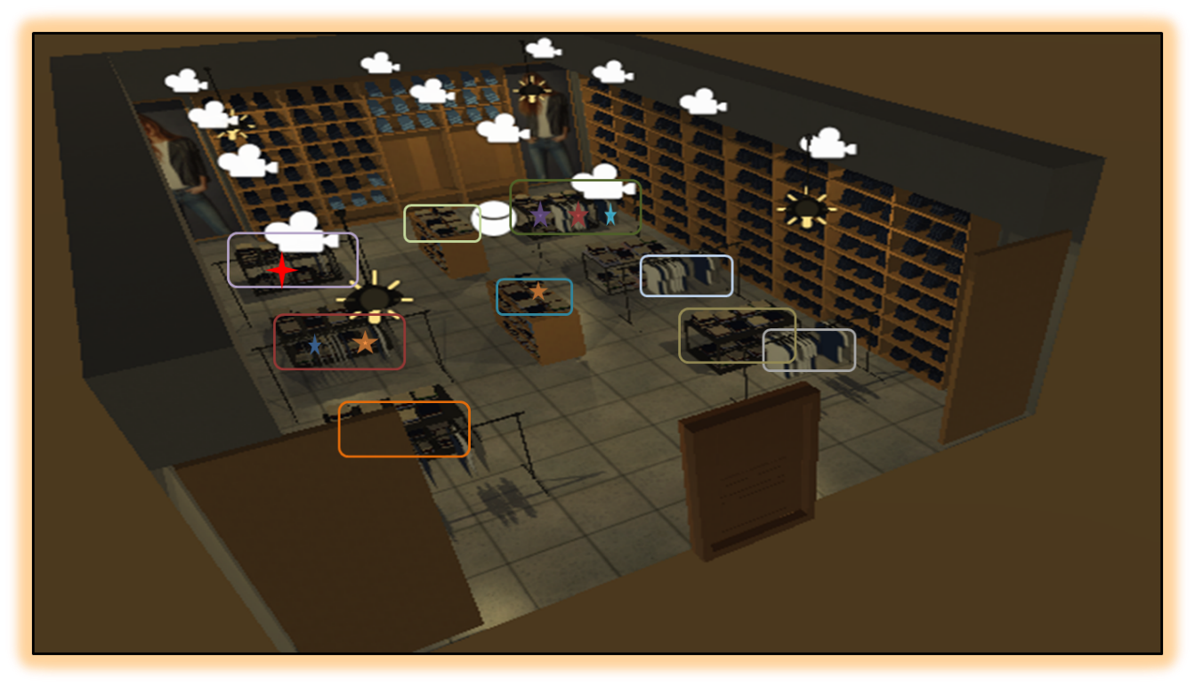

This module takes the ground truth information (clustering done when store is closed), and RFID data taken periodically during store working hours, in order to detect misplaced items.

The following steps are performed:

* Each RFID tag read pattern is taken and its cluster is identified from ground truth
* The distance of RFID tag from the cluster centroid is calculated
* If the distance is beyond a threshold, after adjusting for environmental factors, the tag is considered as misplaced
* Misplaced tag information is sent to reporting module

### Reporting

We would generate a report on misplaced clothing items information, presented in a user friendly format. For example, Levi’s shirt, white color, size 34, is misplaced on table 4. Its original location (of clothes with similar characteristics) is in cupboard 2.

The labeling of furniture items for convenient reference can be done according to the computed ground-truth.

# Implementation Approach & Methodology

## 

## Agile Development Methodology

The development methodology used for this project will be an Agile Scrum method where the set of activities which are a part of the project scope will be executed and delivered as sprints.

At the end of each sprint, a review will happen to determine if the project is on the right path and whether any corrective actions need to be taken. The following block diagram defines the different phases in this methodology and the activities carried out in each phase.

**Principles of Agile Development at RBEI:**

## Requirements Management (Stories)

To define the Customer requirements, user stories have to be created. User stories are more detailed in the form of product backlog items.

Stories make up the product backlog, the release backlog and the sprint backlog. Stories/backlog items are prioritized by the Product Owner to create the product, release, and sprint backlogs for each sprint. From product to release and sprint backlog these backlog items have to be further detailed.

Stories should be written on index cards and should include a role, action and a business value. It is recommended that the following format be used: As a <role>, I want to <action>, in order to <value>. Stories should be categorized by type (feature, technical, non-functional, etc.,) and should be grouped with like/similar stories. Stories can be categorized as blocked if there are questions or technical problems with the story. The Product Owner (and Scrum Master) has to clarify and resolve the open questions or technical issue within one day.

Stories have to be estimated by the Scrum Team to determine complexity and time needed to complete the task. The Product Owner shall be available for further inquiries and provide additional information about a story’s requirements, if there is a conflict on the point estimation. Stories that require more than two person days to complete should be broken into smaller tasks. It is recommended that the estimation process use the planning game and the following point values for estimation: 0, 1, 2, 3, 5, 8, 13, 20, 40 and 100. The full Scrum team commit themselves to the point estimation assigned to each story. The Product Owner may need Scrum Master Supports the methodology with run of the expenditure estimation by methodic tools named at the top ("Planning Game" and point estimation).

## Project Steering and Control

Planning (initial plan, current forecast) and actual values have to be compared. The project status must be reported at regular intervals – at least at every phase transition (project phase or sprint) to the required functions specified by the project organization. The reporting includes schedule progress, cost, scope & quality and risk. Major instruments for development, used by the Scrum Team, are burn down charts and velocity charts.

## Change Management

A change is an alteration to the approved project plan (schedule and/or costs) or a project scope. Target is the systematic handling of change requests. All scope changes are tracked through the product, release or sprint backlogs. Stories can only be added by the Scrum Team to an ongoing sprint.

## Quality Gates / Sprint Assessment

Quality Gates (QG) and Sprint Assessments (SA) have to be conducted within the project plan at the end of each phase. Those quality assessments are designed to be a check point in the project to make sure both RBEI and Intel agree on the current status of product development and that the required tasks are being completed.

Mandatory roles for each QG/SA include: the Project Manager from Intel, the Product Owner from Intel, the Project Manager from RBEI and the Scrum Team.

## Testing

Scrum teams will perform unit testing during each sprint. Integration testing to be performed when all modules are developed and integrated. Product Owner is responsible for validating the functionalities delivered in each sprint. User acceptance testing and live testing to be conducted at the end of integration testing, as indicated in the project plan.

## Sprint Reviews

Sprint reviews will take place regularly. It is recommended that a review should take place at the end of each sprint. The minimum number needs to be determined at the beginning of the project.

The review is moderated by the Scrum Master and should last a maximum of four hours. The full Scrum Team, the Product Owner and all stakeholders should attend the meeting. A demonstration of the running system shall be conducted during the meeting which is recommended to be taken by the Product Owner. Acceptance of the demonstration and test results take place during this meeting.

Information about strengths, weaknesses, expected problems in future sprints, etc. should be discussed and documented during the sprint review meeting. If a so-called retrospective is planned, it should be conducted during this meeting.

## Continuous Code Integration

Continuous integration of code should (if possible) occur frequently. It should also include:

* Code check-in with necessary documentations
* Unit tests
* A full and clean compilation of the application

It is recommended that continuous refactoring of the code be done to optimize the code. The code should be improved before it is checked-in and should adhere to a coding standard. It should include syntax convention, common design patterns, code documentation standards etc. Coding check-style as a tool is recommended to verify that coding standards have been met.

Frequent code reviews are required which needs to be conducted by other members of the RBEI development team as well as technical lead from Intel.

## Quality Assurance

Embedded in the overall concept of quality assurance, we orient ourselves towards the following Quality Assurance Framework to ensure qualitatively high-grade services at the project level:

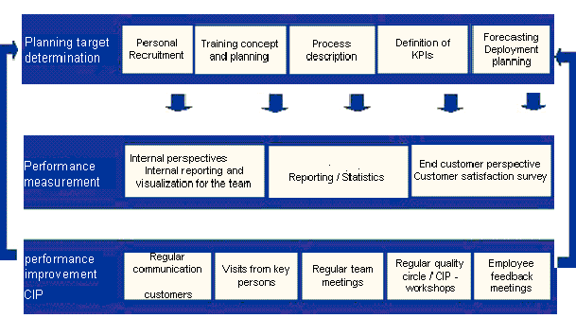

The quality framework consists of three levels:

**Level-1: Planning:**

Planning of the service to be rendered is at the highest level. It involves careful planning of necessary human resources and recruitment of suitable employees, conception of trainings to be carried out, their organizational planning as well as detailed description of the processes covered. In addition, the Key Performance Indicators (KPIs) are defined, which also includes the determination of corresponding reporting for measuring the KPIs as well as forecasting the volumes to be expected and the corresponding personnel deployment planning. The planning is done keeping the project implementation in focus and is adjusted on the basis of the results achieved in the current project.

**Level-2: Performance Measurement:**

The second level describes the performance measurement of the service actually rendered. The quality of service is rendered transparent for both internal jobs as well as for customers through extensive assessments. The rendering of services is looked at from three different perspectives:

* The internal perspective of the RBEI vis-à-vis aspects such as employee, productivity, efficiency etc.
* The perspective of the customers as per the agreed reporting specifications for measurement of the KPIs.
* The perspective of the end customers, who are taken into consideration through e.g. customer satisfaction surveys.

With these measures, a direct feedback is given as to whether the set targets could be achieved or whether individual parameters still have to be adjusted in the planning.

**Level-3: Performance Improvement - Continuous Improvement Process (CIP)**

The third level involves a detailed analysis of the service rendered and the initiation for improvements, which is the CIP. This analysis is carried out in various combinations, starting with regular communication of the responsible contact personnel as well as mutual visits of key personnel during the performance discussions in internal team meetings to the quality circles with all the project participants. Employee feedback discussions for performance improvement of individual employees are also taken into consideration here.

By orienting project plans towards the Quality Assurance Framework it is ensured that this concept is taken into consideration in the project implementation. We plan tasks which are derived concretely from the areas described above (e.g. personnel planning, recruiting, reporting, etc.).Thus, we ensure right from the beginning that the project is promising and can be successfully executed.

## Development Schedule

The overall functionalities are divided into two tracks namely – image processing and analytics. Both the tracks will be executed in parallel. All dependencies between the tracks are considered in the below project plan. However the plan assumes that, all the dependencies from Intel will be address by Intel Project Manager at appropriate times so that team can execute all the tasks as planned.

The project will be executed in agile methodology, with a sprint duration of 4-6 weeks. Details of the sprints and deliverables are mentioned in section 3.11. Scrum teams from Intel and RBEI, along with all stakeholders, will review the development schedule periodically. In case of any change in project scope or schedule, RBEI and Intel Project Managers will discuss and finalize the same and follow the change management process to perform the course correction.

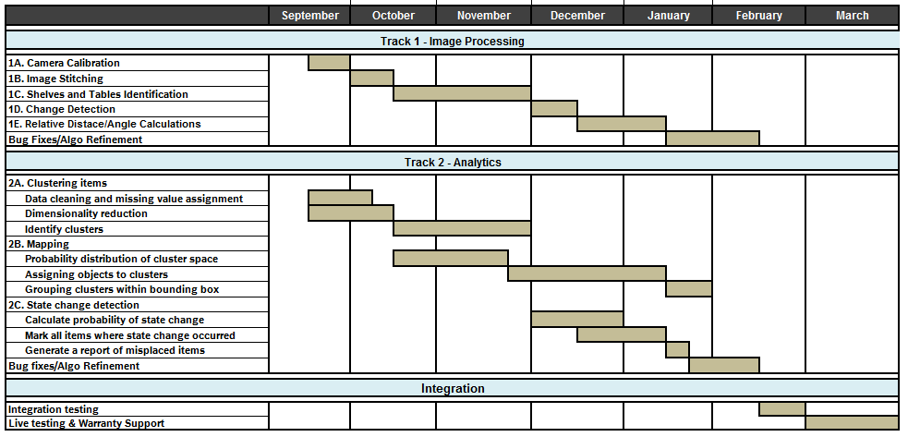

## Proposed Sprint Plan and Activities

RBEI proposes 5 sprints of duration 4-6 weeks to complete all the tasks in scope. The duration of each sprint is not same considering the duration of individual tasks that are part of that sprint. Dependencies between image processing module and development analytics algorithms are also factored in while creating the sprint plan. Deliverables of each sprint are mentioned in section 3.12.

Project Managers, Product Owner and Scrum team will conduct Sprint Planning meetings before commencing each sprint to clarify on the requirements and finalizing the task details. Once a sprint is over, all stakeholders will participate in Sprint Review meeting. The purpose of the Sprint Review meeting is to demonstrate the Sprint deliverables and receive acceptance.

Product Owner from Intel needs to accept and approve the deliverables of each sprint within one week of the Sprint Review meeting. In case of any review feedback during Sprint Review meeting, Scrum Team will estimate the effort and add it to Product Backlog. This will then be taken up as new story in a later Sprint. Below is the sample Sprint plan and associated activities:

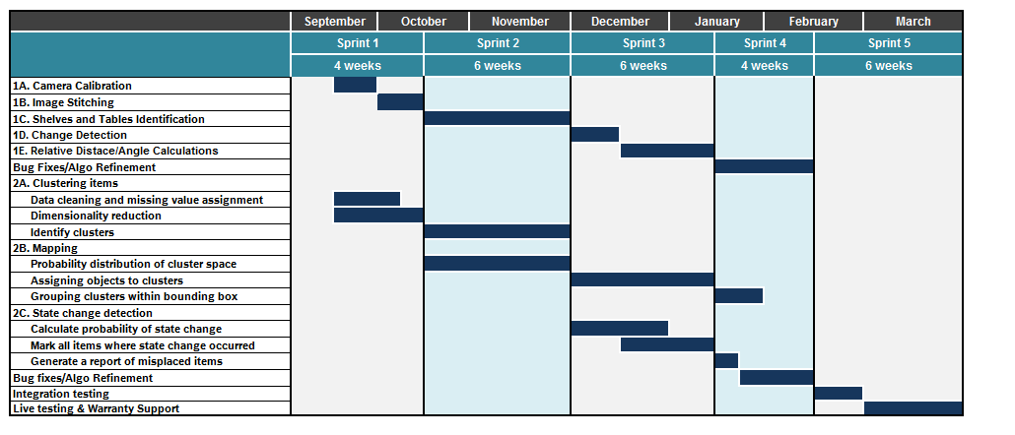

## Deliverables

RBEI Proposes the below mentioned intermediate deliverables in each sprint. We will define billing milestones accordingly. Product Manager from Intel needs to review these deliverables and provide acceptance within one week of Sprint Review meeting.

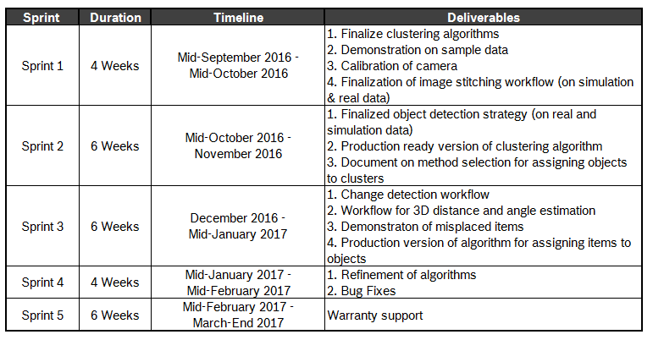

# Additional Details

## Data Requirement:

The following are the data inputs required from Intel for the project implementation:

* RFID data captured
* Ground truth of bounding boxes (table, cupboards, etc.)
* Ground truth of item arrangement in the store
* Store layout
* Images captured from multiple cameras
* Position of RFID antennae and cameras
* RFID antennae range
* RFID sensor read configuration
  + If the signal strength is continuously changed, how is it programmed to change?
  + What are modes in which antenna is operated

(This is required for creating probability space for cluster centroid)

Ideally we would require 3 different sets of store configuration in order to train and validate our models.

## Model Evaluation and Success Criteria:

There are multiple algorithms working together for the final solution. Achievement of the following parameters would be considered as success:

* Detecting >80% of all objects (tables, cupboards, hangers etc) in the store
* Suppose there are “n” clusters from clustering algorithm, 90% of tags within a cluster would belong to same object
* 80% accuracy for cluster to object mapping would be achieved
* Any object misplaced beyond 2 mts would be identified 90% of the time
* Actual position of tag in ground truth would be within 2 mts from estimated position in 90% of cases

## Out of Scope

* The solution deliverable will be findings in the form of python code. Integration and deployment of the model with any existing systems is out of scope for current project (however, we will be providing a shell script for integration to ensure that the different modules developed run in the desired sequence)
* Any changes to original scope or enhancement shall call for re-evaluation of the efforts, time and cost and needs to the change management process
* RBEI assumes that, integration with any other ongoing Intel project is out of scope. In case, any such integration point is required at a later stage, scrum team needs to estimate the effort separately and to follow the change management process
* Creation of reports using any reporting tool is not considered as part of this solution. This being a pilot project, final outputs will be viewed in console by executing Python code or by exporting the end results in a CSV file
* Any coordination required with the retail store in relation to the placement of camera/antennae/ items is to be coordinated by Intel team and considered to be out of scope for RBEI

## Assumptions and Dependencies

* Store area is completely captured by cameras
* RFID reads follow a particular pattern depending on the distance between the tag and reader
* The distribution of reads for a tag is assumed normal on the basis of central limit theorem
* Outcome of every module on blind dataset is shared to Intel team, and feedback in requested metrics (for unit testing of all modules) is provided
* If a tag id is not available when store is open, but available in ground truth, it is assumed that the item is sold and not tracked any further
* Multiple iterations (4-5) will be required to finalize multiple camera mounts and their orientation settings for best results (This needs to be done by stakeholders present at customer area)
* It is best to have the intended cameras mounted in the store before we start development, this avoids rework on calibration, image stitching (parameter tunings), etc.
* For object detection phase, the object training requires multiple images of furniture objects (for positive training) to be captured from target cameras and different parts of the store (for negative case training)
* Evaluation of 3D camera depth maps for possible utilization in object detection phase needs to be done in early phases of the project

## Intellectual Property Rights

As a part of the project activities, there is the possibility of a design of experiment approach for the execution of certain modules of the project leading to collaborative innovation. In case such a patentable solution is developed as part of the project implementation, the patent over the solution will be held jointly by both parties subject to prior discussion and mutual agreement

# Project Management, Reporting and Review Methodology

## Project Management

RBEI will appoint a project manager, he / she will coordinate with Intel for the complete project execution. RBEI – Project Manager is the single point of contact for the project.

## Project Organization

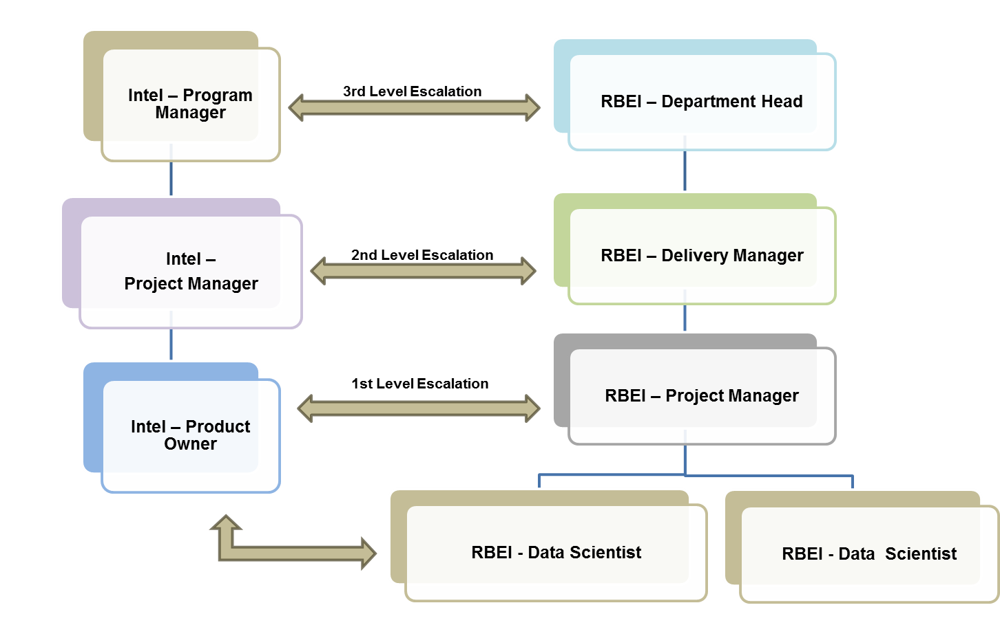

Key roles and responsibilities of RBEI positions mentioned below:

|  |  |
| --- | --- |
| **RBEI** | |
| **Role** | **Responsibility** |
| **Project Manager (Scrum Master)** | * Administrative control of RBEI project team * Project inputs to Intel Program Manager * Provide resources for the project * To resolve issues escalated * Responsible for overall project management * Invoicing/billing * Support in activity planning * Sprint planning & execution * Task allocation and schedule monitoring * Co-ordination with project support and Intel functional architect and Design team * Project planning, tracking and delivery * Clarification for invoicing / billing |
| **Data Scientists (Scrum Team)** | * Work with the Product Owner to analyze and decompose the Product Backlog items * Help create and maintain the Sprint Backlog, Sprint * Demonstrate the product at the end of each Sprint during the Sprint Review * Develop algorithms * Execute designated tasks in each sprint * Implement action items that come out of Retrospectives |

|  |  |
| --- | --- |
| **Intel** | |
| **Role** | **Responsibility** |
| **Program Manager** | * Responsible for project delivery * Overall project responsibility * Participate in joint reviews with RBEI * Approves change requests |
| **Product Owner** | * Providing requirements/clarifications * Prioritization * Deployment schedule * Acceptance testing and deliverables approval |

## Reporting and Review Methodology

|  |  |  |  |  |
| --- | --- | --- | --- | --- |
| **Event** | **Audience** | **Method** | **Frequency** | **Topics** |
| **Weekly Status Reports** | All Stakeholders | Document/ Presentation | Weekly | Summary, Schedule Changes, Bug-Updates |
| **Sprint Planning** | Intel Project Team & RBEI Project Team | Audio / Video Conference / Skype Conference | Beginning of Sprint | Task Prioritization and sprint plan |
| **Sprint Review** | Intel Project Team & RBEI Project Team | Audio / Video Conference / Skype Conference | End of Sprint | Demonstration of Completed Stories & Acceptance |
| **Management Review Meeting** | Management Team | Audio / Video Conference / Skype Conference | Monthly / As needed | Overall Project Status, Risk, Issues etc. |

# Risk Management Approach and Plan

Our risk management process will be used to proactively document and manage risks that may occur during the course of this project. We will work with Organization’s risk management team to ensure that our processes and reporting are well integrated with your enterprise risk management approach.

Risks are managed throughout the project by an early recognition process, getting agreement to the risk and incorporating their resolution in detailed project plans. Each risk is linked to an event trigger on the project schedule, and prior to the events occurring; the relevant risk owner is contacted so that specific risk responses and actions can be formulated. Our Risk Management approach is described as follows:

* **Risk Management Planning:** Typically, we start by defining risks as those issues, which may stop the project from achieving its goals – be accomplished on time, within budget and, achieving its targeted business benefits. Information used in developing the risk management plan may include the project charter, the project organization including roles, responsibilities and authority for decision-making, and any risk management policies, which Organization currently has in place.
* **Risk Identification**: This refers to the proactive identification of risks based on the above definition. Mechanisms are put in place to help ensure that the appropriate communication between project team members and project managers takes place prior to a formal risk being raised to prevent the escalation of risks that can be mitigated within the project team. Identifying risks at all levels puts the project into perspective with other projects within the organization and helps to identify the overall risk impact at an organization level.
* **Risk Analysis**: This refers to the assessment of the probability of an identified risk occurring and the likely impact on the project should the risk occur. Risks are prioritized and categorized to facilitate the allocation of risk mitigation plan development activities and to define risk ownership. Risk escalation levels and processes will be defined.
* **Risk Mitigation**: This refers to the development of strategies and actions to manage or mitigate risk events. It includes the identification and assignment of individuals to take responsibility for developing the strategies and actions for each identified risk. The risk mitigation strategy should be appropriate to the severity of the risk, able to be implemented in a timely manner, and agreed upon by the affected stakeholders. The risk mitigation action plan will be reviewed regularly to help ensure the risk is continuously managed
* **Risk Monitoring, Reporting, and Control:** This refers to the tracking of current risks, the identification of new risks, risk reporting, ensuring the execution of risk action plans, and the evaluation of their effectiveness in reducing risks. Event trigger points will be incorporated as part of the project schedules and will be monitored regularly. This process helps ensure that a complete and accurate view of project risk is obtained. Risk management reports will be prepared and distributed to provide a means of communicating the status of risks affecting the project to various audiences. Risk reporting is a standard component of our project management approach

The objectives of risk management are to identify, address, and eliminate risk items before they become threats to success or major sources of rework. Risk involves the likelihood that an undesirable event will occur, and the severity of the consequences of the event, should it occur. Risk management aims to:

* Identify potential problems and deal with them when it is easier and cheaper to do so - before they are problems and before a crisis exists
* Focus on the project’s objective and consciously look for things that may affect quality throughout the production process
* Allow the early identification of potential problems (the proactive approach) and provide input into management decisions regarding resource allocation
* Involve personnel at all levels of the project; focus their attention on a shared product vision, and provide a mechanism for achieving it
* Increase the chances of project success

## Project Specific Risks and Mitigation

|  |  |  |  |  |
| --- | --- | --- | --- | --- |
| SL No | Risk Description | Mitigation Plan | Contingency Plan | Responsibility |
| 1 | Delay in sign-off of formal agreements (SOW & MSA) and PO – Start of the project will be delayed which has impact on epic execution schedule. | Use Escalation mechanism defined.  RBEI keeps updated daily basis. | Kick off will be planned only after sign-off. Initiate the process as resource ramp up lead time would be minimum of 6 weeks. | RBEI and Intel |
| 2 | Change in scope after baseline | Changes to be evaluated and if necessary, schedule and additional pricing to be discussed and agreed | Prototype driven development. Requirement to be frozen at concept level. | RBEI and Intel |
| 3 | Delay in getting receivables and required clarifications sought by RBEI | Impact on the project schedule to be addressed with Intel to arrive at a workable solution | Intel coordinator proxy to be identified | Intel |
| 4 | Non availability of customer project coordinator (SPoC) | Intel to ensure the availability of SPoC before start of the project | Commitment from Intel Management on SPoC availability | Intel |
| 5 | Unaware of Statutory requirements, legal implications, laws of land | Discuss and address legal implications and statutory obligations with client SPoC |  | Intel |
| 6 | Complex and new concepts may require several validations which may require additional effort or deviation | Prototype approach to clarify concepts. If deviation beyond certain agreeable level effort to be re-estimated and agreed. |  | RBEI and Intel |
| 7 | As clustering is based on number of reads from each antenna, clusters constituents can be from different bounding boxes | Other filtering methods needs to be explored to create clusters within bounding boxes | Intel would need to provide the distance between the reader and the tag or assist in installing reference tags on all objects in the store | RBEI and Intel |
| 8 | As the measurement metrics for clusters and bounding boxes (tables, cupboards etc.) are different, there is a risk of wrong assignment of cluster to bounding boxes | Additional methods such as Gaussian mixture models to avoid such outcomes will be explored | Addition of reference tags to each of the bounding boxes | RBEI and Intel |
| 9 | Possibility of multiple assignment of a single cluster based on probability score | Need to explore options of multiple models or elimination methods |  | RBEI |
| 10 | Presence of new RFID tags not present in the ground truth (during replenishment?) | To be classified as a “new item” |  | RBEI |
| 11 | Unreliable estimation of depth cues from SFM | Usage of Depth Maps from 3D Camera | Pre-stored database of furniture parameters (e.g. height of the table) | RBEI and Intel |
| 12 | Unreliable object detection from using only 2D images | Usage of 3D Depth Camera for getting additional cues |  | RBEI and Intel |

# Project Estimation and Commercial Summary

Development Project Cost

|  |  |
| --- | --- |
| **Deliverables** | **Cost (USD)** |
| Computer Vision overall project delivery | 215000 |
| **Total Costs** | **215000** |

Payment Schedule

| # | Milestone | Payment Percentage on Total Cost |
| --- | --- | --- |
| 1 | Delivery acceptance of Sprint 2 | 25% |
| 2 | Delivery acceptance of Sprint 3 | 25% |
| 3 | Delivery acceptance of Sprint 4 | 20% |
| 4 | Project Completion | 30% |

# Terms and Conditions

**General:**

* Project kickoff: RBEI will need 1 week lead time to start the project
* Project Termination: In case of project termination, Intel shall intimate the RBEI team at least 1 month in advance. If the engagement is terminated prematurely, Intel shall be liable to pay service cost incurred for a period of 1 month
* This document is a proposal submitted by RBEI to Intel and is valid up to November 30th, 2016
* Price does not include any hardware or software procurement cost
* Details regarding timeline, start date, etc. will be finalized at the time of kick-off and the team will be formed as per the project plan

**Commercial:**

* Intel will issue a PO before the start of the project
* In addition an SOW document needs to be signed between both parties
* RBEI will raise invoice at the end of each milestone completion as per billing schedule indicated in the document
* Any taxes applicable will be billed at actuals
* Intel will make payments within 30 days from the date of invoice

# Business Contacts

|  |  |
| --- | --- |
| ***Sales Representative:*** | |
| *Name:* | Mahesh Chikodi |
| *Telephone:* | +44-1895-83-8653 |
| *Mobile:* | +44-779-296-4789 |
| *E-Mail:* | [Mahesh.Chikodi2@uk.bosch.com](mailto:Mahesh.Chikodi2@uk.bosch.com) |

|  |  |
| --- | --- |
| ***Project Management Contact:*** | |
| *Name :* | Aritra Basu |
| *Telephone:* | +91(80)6657-1588 |
| *Mobile:* | +91 (95)35364646 |
| *E-Mail:* | [Aritra.Basu@in.bosch.com](mailto:aritra.basu@in.bosch.com) |